Mesopotamia

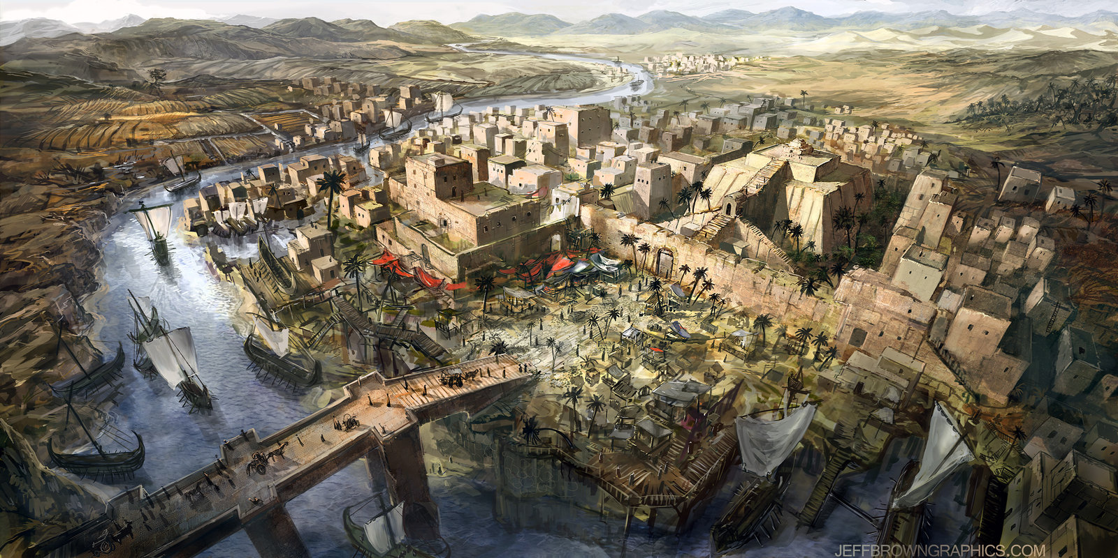

Mr. Dellinger

Government / Military

City-States of Sumer (Module 3, lesson 2)

Akkadian Empire (Module 3, lesson 2)

Babylon (Module 3, lesson 3)

The Assyrians (Module 3, lesson 3)

The Chaldeans (Module 3, lesson 3)

The Persians (Module 3, lesson 5)

Religion

City-States of Sumer

Akkadian Empire

Babylon

The Assyrians

The Chaldeans

The Persians

Society / Social Classes

City-States of Sumer

Akkadian Empire

Babylon

The Assyrians

The Chaldeans

The Persians

Writing

City-States of Sumer

Akkadian Empire

Babylon

The Assyrians

The Chaldeans

The Persians

Arts / Architecture

City-States of Sumer

Akkadian Empire

Babylon

The Assyrians

The Chaldeans

The Persians

Advances / Inventions

City-States of Sumer

Akkadian Empire

Babylon

The Assyrians

The Chaldeans

The Persians

