Julius Caesar Activity
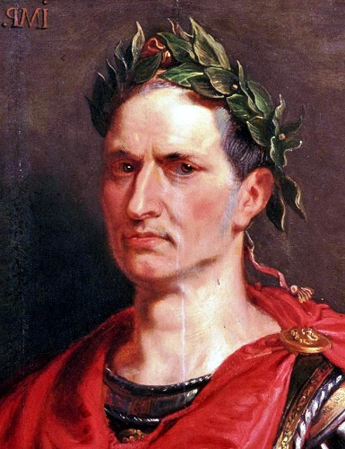
Step 1: Read the following three articles about Julius Caesar and his life:
- A Portrait of Julius Caesar
http://www.eyewitnesstohistory.com/caesar3.htm

- Julius Caesar Cross the Rubicon, 49 B.C.
http://www.eyewitnesstohistory.com/caesar.htm

- The Assassination of Julius Caesar
http://www.eyewitnesstohistory.com/caesar2.htm

Step 2: Answer the following questions on a separate piece of paper:
- What were Caesar’s good qualities or characteristics?
- What were Caesar’s bad qualities or characteristics?
- Who supported Caesar?
- Who was against Caesar?
- How did Caesar justify his actions?
- How does history portray Caesar?

Step 3: You create either a ‘Man of the Year’ or ‘Rome’s Most Wanted’ poster about Caesar. Posters should include a visual and a paragraph (eight sentences or more) providing evidence to support your position.

