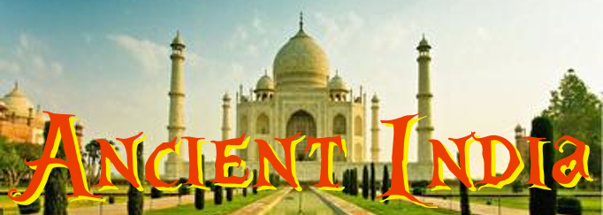
STUDY GUIDE

- Define “subcontinent”, and describe how India is an example of a subcontinent.
- Why would soil be fertile near the Bay of Bengal?
- Using a map of India, which areas in India would have fertile farmland?
- How did the location of the Himalaya Mountains help India?
- What things might a traveler see in the Thar Desert?
- How are the Indus and Ganges rivers of India similar to the Nile River of Egypt?
- Which civilization developed in the Indus River Valley?
- Which two major world religions began in the Indian subcontinent?
- List the jobs/roles of all members of the caste system.
- Why did Untouchables live in separate communities than everyone else?
- Describe the Four Noble Truths and the Eightfold Path of Buddhism.
- Create a timeline listing the rulers of Ancient India during the Mauryan and Gupta empires.
- How was Ashoka impacted by Buddhism?
- List some of the important skills and achievements of the people in Ancient India.
- Which caste was the largest, made up of mostly peasants?
- Which caste was made up of priests, teachers and judges, at the top of the caste system?
- What was the name of the warrior caste, that helped run the government?
- Which caste consisted of skilled workers, merchants, and landowners?
- Which religion teaches that there are many gods that are part of one supreme god or life force, and supports ideas of karma, dharma, and reincarnation?
- Describe how Buddhism spread throughout India and the rest of Asia.
- What can be learned by different statues that were found from ancient Indian civilizations?
- List some examples about how family was important in Hindu beliefs?
- How did Hindus believe karma might affect your life and reincarnation?
- According to Hinduism, if you continue to want wealth and power, how might this affect your karma?
- How did the caste system separate people?
- Describe the impact the Aryan invasion had on Indian society.
- Define & describe monsoons.
- Which two cities served as twin capitals in ancient India?
- Define/describe karma.
- Which religion taught that the four noble truths and eightfold path lead to nirvana?
- What effect did Emperor Ashoka have on Buddhism?
- What three things did the Aryans bring with them that impacted culture in ancient India?
- Hindus believed the soul’s union with Brahman was guided by karma and dharma, but the journey also took several cycles of what?
- How did Siddhartha Guatama, the Buddha, find the answer for human suffering?
- Buddhists believe in reincarnation and union with the universe in a state of total peace of complete happiness, which is also known as what?
- What do the civilizations of Mesopotamia, Egypt and India have in common?

